CSE 4321/5321 Homework 1

Spring 2019

Problem 1-5 - 14 percent each, problem 5 - 30 percent.

Guidance for all problems:

1. Develop the minimum set of test cases needed to adequately test all actions and boundary values.
2. List all inputs and expected outputs using the test case table depicted in the previous HW 1 solution. Only show essential inputs and outputs - do not show intermediate values in your test case tables.
3. Develop the test needed for all partitions with two test cases per partition.
4. Assume that currency is truncated and significant to the Cent.
5. Clarify any assumptions made with the professor - do not change the function of the problem.
6. Values shown must have thousands separators and reflect the units being depicted. Significance shown must reflect the units being depicted.

The following are customer descriptions of software scenarios.

1) Arlington Financial is an investment management software that helps its customers keep track of shares bought of Shorthorn Technology Ltd (STL) and calculates the portfolio amount. The Portfolio amount is defined as total value of all shares including dividends received and fees paid, if any. The software keeps track of the customer’s portfolio amount, status of the customer and the amount of brokerage fees paid by the customer. For shares between 150 and 375, the dividend received is 1.125%. If the number of shares owned is less than or equal to 150, STL pays a dividend of 0.785%. For shares greater than or equal to 375, the dividend received is 1.825%. For shares greater than 600, the dividend received is 2.085%. For shares greater than 800, the dividend received is 2.45%. For shares above 1250, the dividend received is 3.45%. If a customer has more than 500 shares, he/she is required to pay a brokerage fee of $100, which is automatically deducted from the dividend. A customer receives a “Prime” status, when his/her share amount is greater than 5,000 shares. Use below given formulas for your calculation:

Value of Shares = Number of Shares \* Value of each share

Dividend Received = Dividend% \* Value of Shares

Portfolio Amount is the total value of all shares, plus dividends, minus fees.

Assumptions for this problem:

1. Assume the closing price of a STL share is $135.00.

2. Customers are only allowed to own whole, non-negative shares. Assume the largest stockowner has 10,000 shares of STL.

3. Assume a non-Prime status is called Regular.

The test case table should show Number of shares as an input and Portfolio Amount and Customer Status as expected outputs.

2) A 2-engine UAV uses the following forward velocity rates: when the drone is over 200 feet above the ground, 20 fps, otherwise when at 150 feet and over, 10 fps, otherwise when over 100 feet above the ground, 7.5 fps, otherwise when at 50 feet and over, 5 fps, otherwise when at 10 feet and above, 2 fps, and otherwise the forward velocity is 0 fps and the motor is turned to "off". Drone altitude and forward velocity are both doubles with 0.1 significance.

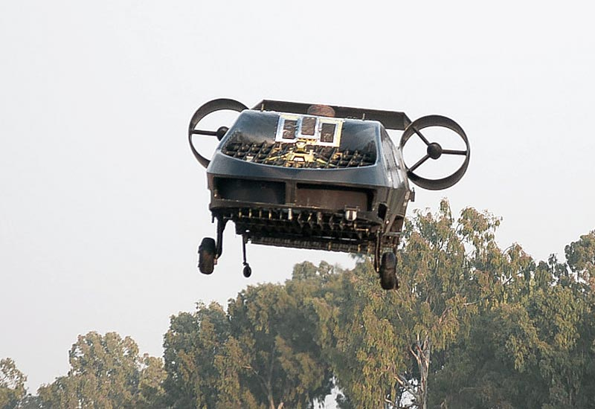

Test table: Inputs aag (altitude above ground in feet), expected outputs: forward velocity and motor status {Off, On}.

Assume: Altitude is 0 to 300 feet both inclusive. Drone forward velocity is a single double set by the software. Motor status either turns both motors on or off.

3) Arlington Auto introduces an automobile safety system known as the Collision Warning System (CWS) with brake support. CWS calculates the distance between the car and the vehicle ahead of the car and alerts the driver with visual and/or audible warning and prevent a collision by helping the driver to maintain a safe following distance. The car is installed with green light, yellow light, red light and a buzzer. If the distance between the car and the vehicle ahead of the car is greater than 200 feet, the green light will be ON indicating the car is travelling at a safe distance. If the distance between the car and the vehicle ahead is 200 feet or less, the yellow light is ON (indicating an possible danger) and if the distance is less than 100 feet the RED light is ON (indicating an imminent danger). If the distance between the car and the vehicle ahead is less than 75 feet, the BUZZER is turned ON and less than or equal to 50 feet, the brakes will be applied automatically.

Additional guidance:

1. Assume all values are Java doubles with a significance of 0.1.
2. All lights are off when not specifically turned on.
3. When the car first starts, all alerts reset (off), but the software immediately sets one of the output sensors based on distance - this means that you do not need to test the all outputs off case - the "all alerts reset" condition is only mentioned to indicate that no indicators are left on from a previous power cycle.
4. Distances cannot be negative. Assume the maximum distance is 1,000 feet due to the range of the sensor.

Test Case table will show inputs of distance (ft) and Expected Outputs of Green, Yellow, Red, Buzzer, and Brakes (each will show ON or OFF).

4) Arlington Financial (Question 1) has acquired a huge customer base, and around 33% of its total customers have achieved the Prime status. In order to better recognize their prime customers, they have now decided to replace the previous recognition ("Prime") with a new recognition scheme: “Silver” status for customers with portfolio amount after dividends and fees greater than or equal to $300,000.00; “Gold” for customers with portfolio amount after dividends and fees greater than or equal to $400,000.00; and “Platinum” for customers with portfolio amount after dividends and fees greater than or equal to $750,000.00.

Additional Guidance:

1. Update your test case table from Problem 1 to show the new table
2. Note: use the same inputs and expected outputs as problem 1 but update these for the new share values.

5) Convert the first three problems above into decision tables. Divide this problem into parts a) b) and c) for problem 1, 2 and 3 respectively. For each, provide

1. the decision table. Use slide 61 M03 as a guideline.
2. the number of test cases required (do not supply the specific test cases)
3. does this number agree with the number of tests developed above? Yes or No. If no, why not?

6) Arlington Appliance has implemented a ceiling fan with a digital interface. The interface has four widgets: one that increases the fan speed, one that decreases the fan speed, one that turns the light on and one that turns the light off. The speed output is represented as an enumeration type with the following values {Off, Low, Med, High}. The fan speed starts in off. Increasing the fan speed causes it to go to the next highest speed - but High goes to Off. Decreasing the fan speed causes it to go to the next lowest speed - but decreasing from Off stays in Off (for safety reasons). The light output is represented as an enumeration type with the following values {Off, On} and starts with the light off. Draw the simplest state diagram (Mealy) and state table with all inputs and expected outputs depicted. The state diagram may be hand drawn and a picture submitted, BUT the submitted picture must be gradable.

In your diagram and your state table use as inputs I, D, O, and X = T or F. As an example, show these as I (I=T) or !I (I=F). Show outputs as S=Off, Low, Med, or High and L=Off or On. Each state must show all inputs and outputs. Assume only one input is set true at a time. Do not show F (false) inputs unless the logic requires it.

Label each state S0 through Sn, with S0 showing the Start event.